From Rules to Residues: Demystifying Large Language Models via Ground-Up Structural Implementation
Mayank Kumar Sharma
IEM Newtown,
Kolkata, India
Abstract—Modern natural language processing is dominated by Large Language Models (LLMs) centered on the Transformer architecture. While frequently abstracted as speculative entities possessing emergent cognitive reasoning, this paper systematically reduces the LLM pipeline to its baseline deterministic components: tokenization via Byte Pair Encoding (BPE), distributional semantic vector generation (Word2Vec/embeddings), and matrix-multiplication-driven self-attention. By contextualizing a 52,000-parameter toy model built completely from scratch against 80 years of computational history, we evaluate the paradigm shift from handwritten, rule-based heuristics to statistical next-token auto-regressive generation. Finally, we discuss how fine-tuning frameworks like Reinforcement Learning from Human Feedback (RLHF) and external tool-calling execution environments shape a statistical autocomplete model into an apparent conversational agent.
Keywords—Large Language Models; Transformer; Self-Attention; Tokenization; Byte Pair Encoding; Auto-regressive Generation.
I. INTRODUCTION
For nearly three-quarters of a century, the pursuit of human-machine conversational parity has been framed by the Turing Test. Originally proposed as a conceptual benchmark for mechanical intelligence, early attempts to cross this threshold relied heavily on rigid, rule-based algorithmic structures. Joseph Weizenbaum’s Eliza (1966) utilized primitive string pattern-matching heuristics and simple script decomposition to simulate a Rogerian psychotherapist. Despite its lack of an internal semantic representation, Eliza proved that minimal user exposure to deterministic if-else constraints could induce an anthropomorphic illusion of deep intelligence—a psychological phenomenon later categorized as the "Eliza Effect". Subsequent configurations, such as Kenneth Colby’s Parry (1972), introduced basic belief networks to simulate paranoid states, while systems like the Artificial Linguistic Internet Computer Entity (A.L.I.C.E.) in 1995 scaled the sheer volume of these pre-programmed conditions using recursive template languages like AIML. Yet, regardless of corporate scaling or rule density, these structural architectures failed completely to establish true language understanding, acting instead as complex mirror systems for human projection.
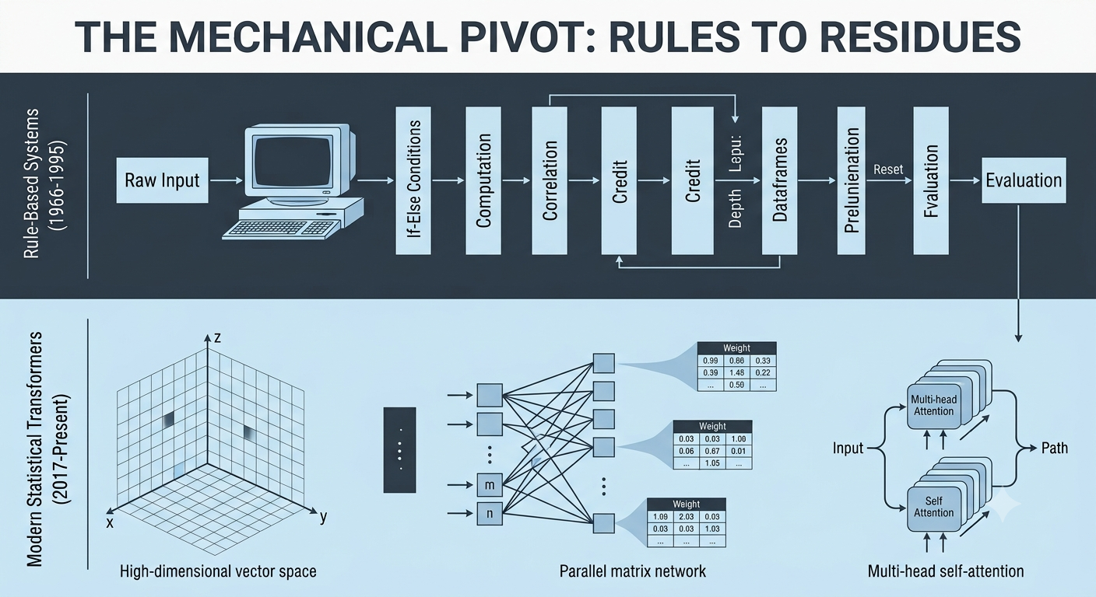
Fig. 1
This mechanical pivot acknowledges that meaning is fundamentally contextual, shifting the engineering challenge from rule generation to high-dimensional optimization, as illustrated in Fig. 1
The contemporary transition to Large Language Models (LLMs) represents a fundamental mechanical divergence from the handcrafted heuristics of the 20th century. Rather than relying on human engineers to meticulously script predefined logical pathways or hardcode syntactic boundaries, modern deep learning architectures leverage empirical distributional statistics across massive, multi-gigabyte textual corpora. Under this paradigm, natural language is treated not as a static set of grammatical constraints, but as a deep structural continuum containing predictable statistical regularities. This mechanical pivot acknowledges that meaning is fundamentally contextual, shifting the engineering challenge from rule generation to high-dimensional optimization. By framing language as a sequence of discrete, probabilistic choices, modern deep learning networks learn to optimize internal parameter matrices that approximate the underlying structural geometry of human communication.
Consequently, the core engineering problem resolves to establishing an efficient, multi-layered computational engine capable of map-reducing sequence data. To understand these contemporary architectures, one must dismantle the abstraction layers that obscure their mathematical reality. This paper provides a comprehensive, bottom-up engineering review of the mathematical and algorithmic pipeline necessary to implement an auto-regressive text generator from scratch. By reducing the complex operational lifecycle of modern transformer architectures to baseline deterministic blocks, we map the entire pipeline from raw character arrays to normalized output distributions.
II. THE CORE COMPUTATIONAL UNIT: THE MULTI-LAYER NEURAL NETWORK
A. From Biological Blueprints to Logical Primitives
The mathematical substrate of contemporary large language models is not an overnight artifact of the deep learning
boom; rather, it is the realization of a century-long effort to abstract biological cognition into mathematical operations.
The architecture & lineage begins with Warren McCulloch and Walter Pitts in 1943, who sought to understand how the
physical architecture of the brain could generate thought. They conceptualized biological neurons as binary threshold
devices—primitive logic gates that remained dormant until their combined pre-synaptic electrical inputs crossed a precise
activation barrier. By formalizing this mechanism, they demonstrated a profound computational truth: networks of these
idealized binary neurons were capable of universal logical computation, meaning they could theoretically calculate any
arithmetic or logical function given the correct manual configuration of connective wiring.

However, the McCulloch-Pitts neuron was fundamentally static. It possessed no internal learning mechanism; its
and structural thresholds had to be laboriously pre-engineered and hardcoded by hand. This major limitation
was shattered in 1958 when Frank Rosenblatt introduced the Perceptron. Built as a physical custom machine using an
array of motor-driven potentiometers and optical sensors, the Perceptron allowed a single artificial neuron to dynamically
adjust its own internal weights based on environmental feedback.

f(X) = 1 if ∑(w_i * x_i) + b ≥ 0 else 0

If the machine misclassified a pattern during training, an elegant error-correction rule automatically incremented or
decremented the scalar weights in the direction of the target value. The absolute simplicity of this algorithm triggered a
wave of speculative optimization, with practitioners predicting imminent human-machine parity.

B. The Minsky-Papert Wall and Hidden Manifolds

This initial momentum came to an abrupt halt in 1969. Marvin Minsky and Seymour Papert published a rigorous
geometric critique that exposed a critical mathematical boundary of the single-layer perceptron: it was strictly bound to
linear classification tasks. Because a single neuron splits its coordinate space using a straight decision boundary (a
hyperplane), it could only classify datasets that were completely linearly separable. Minsky and Papert proved that the
simplest logical function requiring a non-linear split—the Exclusive OR (XOR) problem—could not be resolved by a
single-layer perceptron.

Input x1 | Input x2 | XOR Output
0 | 0 | 0
0 | 1 | 1
1 | 0 | 1
1 | 1 | 0
TABLE I: XOR Truth Table Configuration
Plotted on a two-dimensional grid, the matching outputs (1s) sit diagonally across from the non-matching coordinates (0s). It is geometrically impossible to draw a single straight line that isolates the active states from the inactive ones. Because language is inherently non-linear and packed with complex context rules, this mathematical limitation effectively froze neural network research for over a decade.
The breakthrough that resolved this bottleneck was the implementation of multi-layer feedforward networks, often called Multi-Layer Perceptrons (MLPs). By stacking intermediate "hidden" layers of neurons between the raw inputs and the final output layer, the network gains the ability to project data into higher-dimensional mathematical manifolds. Within these elevated coordinate spaces, rigid data structures are warped and untangled, allowing a final linear hyperplane to accurately segment them.
To achieve this spatial warping, hidden layers must utilize non-linear activation functions. If hidden layers are stacked without non-linear activations, the entire network simply collapses back into a single linear equation, because a matrix multiplication of a matrix multiplication is mathematically equivalent to a single combined matrix transformation. Early multi-layer networks utilized smooth, S-shaped curves like the Sigmoid function or the Hyperbolic Tangent (σ(z) = 1 / (1 + e^-z)) to introduce this non-linearity.

C. Backpropagation and the Chain Rule Optimization
While adding hidden layers solved the geometric limitations of single-layer networks, it introduced a major engineering challenge: how does a system calculate the correct error metrics for an internal hidden neuron that has no direct contact with the external training target? This credit-assignment problem was solved in 1986 when David Rumelhart, Geoffrey Hinton, and Ronald Williams formalized the backpropagation algorithm.
The training cycle of a multi-layer neural network operates as a two-stage thermodynamic loop. First, input features are propagated forward through successive weight matrices (W) and biases (b). For a given layer l, the incoming signal is combined as an intermediate state z, which is then passed through an activation function to yield the layer's output activation. This forward propagation continues until the final layer produces an unnormalized set of raw predictions, or logits. These predictions are evaluated against the true ground-truth targets using a scalar cost function, or loss function. For multi-class prediction and sequence generation tasks, models rely on Cross-Entropy Loss to measure the divergence between the predicted probability distribution and the actual target distribution.
Once the scalar loss value is calculated, the backpropagation pass begins. The algorithm uses the mathematical chain rule from calculus to calculate how much every individual weight and bias in the network contributed to the final output error. It computes the partial derivative of the error function with respect to each weight matrix (dE/dW), effectively measuring how a tiny adjustment to a single parameter changes the global error rate.
∂E / ∂w_ji = (∂E / ∂a_j) * (∂a_j / ∂z_j) * (∂z_j / ∂w_ji)
This calculation yields a precise error gradient vector. This vector acts as a multi-dimensional compass, pointing directly toward the mathematical choices that caused the misclassification. Using the calculated gradients, an optimization algorithm adjusts the network's parameters. In classic Stochastic Gradient Descent (SGD), parameters are shifted by subtracting a small portion of the gradient vector, controlled by a scalar factor called the learning rate. Modern large language models typically use the AdamW optimizer, a more advanced variation that scales learning rates dynamically for each parameter based on running historical averages. By repeating this forward-and-backward cycle across millions of textual training samples, random initialized matrices gradually organize into structured representations, laying the mathematical foundation for processing natural language.
III. DATA PRE-PROCESSING & TOKENIZATION HEURISTICS
A. Foundations of Linguistic Numerical Translation
A neural network cannot natively process raw string characters; it operates exclusively on numerical vectors. Therefore, raw text must be decomposed into granular mathematical primitives called tokens. Modern Large Language Models (LLMs) utilize the Byte Pair Encoding (BPE) algorithm—originally developed by Philip Gage in 1994 for general data compression routines and later adapted by Sennrich et al. in 2015 for neural language vocabulary optimization. Before the widespread adoption of BPE, early language systems relied heavily on word-level or character-level representations. Word-level models, while preserving intuitive semantic mappings, catastrophically failed when encountering out-of-vocabulary (OOV) neologisms, specialized technical notation, or typographical variants. Conversely, purely character-level networks completely eliminated OOV errors but forced models to expend massive sequence lengths and architectural memory capacity over raw, meaning-sparse individual letters. BPE gracefully bridges this chasm by constructing an adaptive subword lexicon that balances computational footprint against granular linguistic expressiveness.
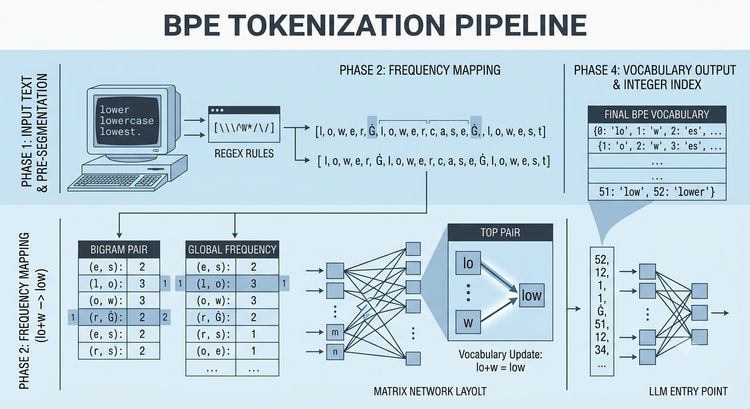
Fig 2
By establishing highly flexible subword tokens, networks preserve optimal structural contexts while processing unfamiliar terms by splitting them into coherent constituent roots and affixes. This adaptive grouping fundamentally allows a modern neural architecture to scale across vast internet-scale text corpora. The linguistic translation pipeline translates raw characters into deterministic discrete integer indices, providing a systematic mathematical mapping that acts as the entry point for deep computational encoders.
B. Inductive Vocabulary Construction Pipeline
Byte Pair Encoding builds a language vocabulary inductively from raw text corpuses through a strict, multi-stage compilation pipeline. The initialization phase begins by treating every base character in the training corpus as a standalone, primitive token string. The systematic pipeline progresses through three deterministic algorithmic phases:
1) Pre-segmentation: Raw training strings are passed through a series of deterministic regular expressions (regex) to partition text cleanly along word boundaries, punctuation marks, and structural line changes. This phase prevents invalid cross-word character merges from corrupting the structural integrity of the token definitions. For instance, spaces are explicitly preserved using distinct placeholder marks (such as the 'Ġ' block visible in modern GPT-based tokenizers), ensuring that words remain mathematically distinct throughout subsequent iterative merging steps.
2) Frequency Mapping: The underlying base character distributions and adjacent character pair frequencies are tracked, mapped, and dynamically updated across the total training data corpus weightings. The tokenizer scans the serialized token array, tallying every consecutive co-occurrence of adjacent bigram units to establish a precise global statistical frequency map.
3) Iterative Merging: The single most frequently occurring adjacent character or subword pair discovered within the statistical frequency map is consecutively merged into a singular, newly minted vocabulary unit. This process dynamically updates the overall text representation by modifying all matching contiguous bigrams across the corpus. This continuous loop repeats iteratively until either a pre-designated vocabulary ceiling or a maximum merge allocation constraint is formally reached.
To illustrate this mechanism dynamically, the iterative merging iterations over a sample micro-corpus are tracked in the structural evaluation below:
Iteration Step | Target Corpus Representation | Top Co-occurrence Pair | New Vocabulary Addition
Initialization | l o w e r Ġ l o w e s t Ġ n e w e s t | N/A | {l, o, w, e, r, s, t, n, Ġ}
Merge Step 1 | l o w e r Ġ l o w e s t Ġ n e w e s t | (e, s) -> 'es' (Freq: 2) | Add 'es' to Vocabulary
Merge Step 2 | l o w e r Ġ l o w e s t Ġ n e w e s t | (es, t) -> 'est' (Freq: 2) | Add 'est' to Vocabulary
Merge Step 3 | l o w e r Ġ l o w e s t Ġ n e w e s t | (l, o) -> 'lo' (Freq: 2) | Add 'lo' to Vocabulary
TABLE II: Inductive Subword Merging and Vocabulary Generation States
C. Byte-Level Fallbacks and Out-of-Vocabulary Resilience
While standard character-based BPE solved a major portion of the vocabulary challenge, it still suffered from a subtle vulnerability: if the training corpus missed specific Unicode character variations, emojis, or foreign localized symbols entirely, the runtime tokenizer would fail when processing those unexpected characters in production settings. To address this exact problem, modern state-of-the-art architectures like GPT-4 and LLaMA utilize an optimized variation called Byte-Level BPE (BBPE). Instead of building the initial vocabulary using raw unicode characters, BBPE forces the model to construct its base vocabulary using the 256 fundamental, immutable raw byte values.
By shifting the baseline abstraction layer from complex characters down to primitive raw bytes, the vocabulary completely eliminates the need for an out-of-vocabulary fallback symbol. Every arbitrary string of text, regardless of its localized dialect, obscure formatting, or structural layout, can be broken down into its core underlying bytes and processed deterministically. This modification prevents critical processing crashes when handling complex multi-lingual web text, ensuring that the underlying tokenization layer remains highly stable and resilient under all runtime input scenarios.
D. Algorithmic Efficiency and Inverted Index Implementations
Executing an unoptimized Byte Pair Encoding lookup across massive internet-scale databases poses significant computational hurdles. A naive scanning approach would require recalculating global bigram distributions across gigabytes of strings during every single merge step, resulting in a prohibitive time complexity curve. To achieve production-grade performance, commercial implementations employ an inverted index system. This system maps each individual token pair directly to its exact structural offset positions across the entire training corpus text sequence.
When a top-frequency bigram pair is selected for a merge operation, the tokenizer queries the inverted index to modify only the specific positions affected by that change. It then updates the statistical frequencies of adjacent pairs directly impacted by the localized merge, bypassing the need for expensive global recalculation passes. This specialized data structure optimization reduces the execution time of the tokenization process, allowing developers to routinely compile multi-billion-parameter vocabularies across petabyte-scale training datasets without experiencing architectural bottlenecks.
The trade-offs between various tokenization strategies are summarized in the comparative table below:
Tokenization Method | Vocabulary Dimension | Average Sequence Length Ratio | Out-of-Vocabulary (OOV) Risk State
Word-Level Tokenizer | Large (100K - 1M+) | Compact (1.0x Base) | High Risk (Frequent Unseen Drops)
Character-Level Tokenizer | Minimal (256 - 1K) | Verbose (4.0x - 6.0x Expansion) | Absolute Zero OOV Risk
Byte-Level BPE (BBPE) | Balanced (32K - 128K) | Optimized (1.2x - 1.5x Scaling) | Absolute Zero OOV Risk (Byte-Safe)
TABLE III: Comparative Architectural Profiling of Tokenization Metrics
Ultimately, the balance achieved by subword heuristics like Byte Pair Encoding ensures that contemporary architectures remain robust against unpredictable language inputs while keeping sequence lengths short enough to maintain efficient training steps across deep neural layers.
IV. DISTRIBUTIONAL SEMANTICS AND VECTOR EMBEDDINGS
- The Structural Geometry of Meaning
Once text strings are parsed and successfully indexed into discrete integer token IDs, they must be projected into a continuous geometric space where vector proximity implies deep semantic correlation. A static list of numbers cannot capture nuance; if tokens are treated as simple independent coordinates, an automated framework can never distinguish the contextual similarity between related concepts. This conceptual breakthrough relies entirely on J.R. Firth's iconic 1957 theory of distributional semantics, famously captured by his structural aphorism: "You shall know a word by the company it keeps." In the mathematical domain, this means that tokens that repeatedly appear within matching linguistic neighborhoods ought to be mapped to nearly identical regions within a multi-dimensional coordinate landscape.
To establish this topological behavior, the system maps localized text patterns to dense geometric representations. Instead of representing a word using an empty, isolated placeholder index, the system translates tokens into multi-dimensional vectors. Within this unified geometric space, the distance and direction between coordinates represent complex linguistic behaviors, providing the foundational structural baseline required for down-stream transformer attention architectures.
B. Mathematical Optimization and Context-Window Frameworks
In practical neural applications, this dense projection is constructed by initializing a randomized continuous weight matrix array of size (Vocabulary Size × Embedding Dimension). At the start of the optimization pipeline, these vectors point in arbitrary random directions, possessing no underlying structural insight. By using optimized architectures like Word2Vec, developed by Mikolov et al. in 2013, the underlying network iteratively updates these vector parameters via an algorithmic context-window loop that slides smoothly across vast textual datasets.
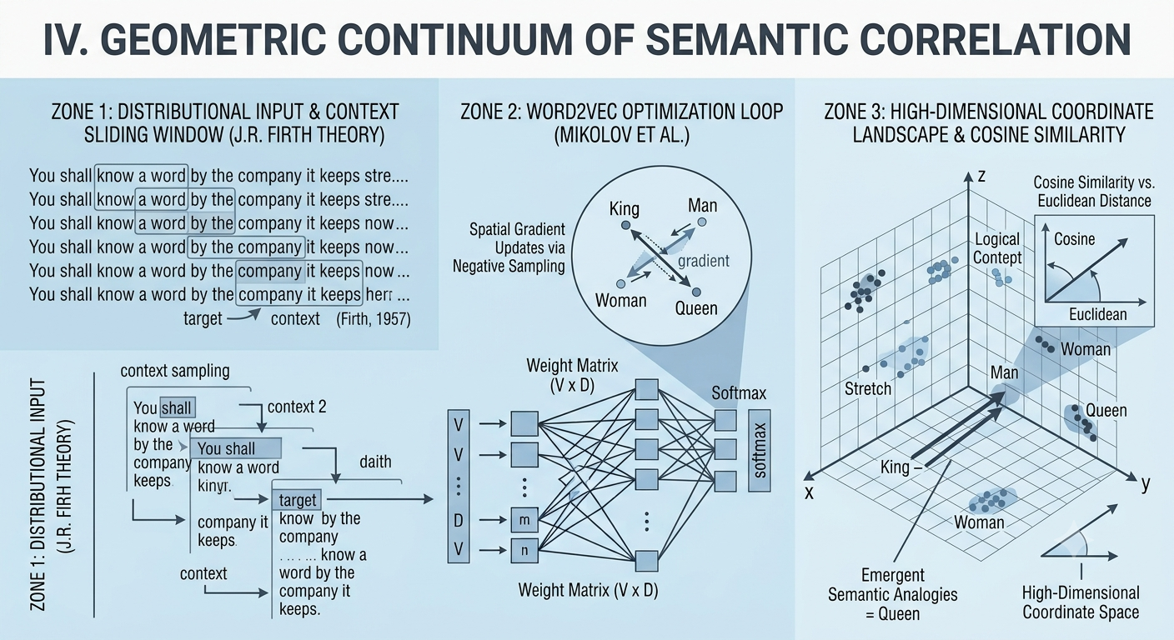
Fig 3
In a standard Skip-gram implementation, target words are systematically isolated and paired against surrounding context tokens located within a precise tracking radius. The primary goal of the network is to optimize its parameters to maximize the conditional probability of predicting these neighboring tokens. For a given target word sequence, the objective function seeks to maximize the average log probability across its localized window bounds:
L = (1 / T) ∑_{t=1}^T ∑_{-c ≤ j ≤ c, j ≠ 0} log P(w_{t+j} | w_t)
The conditional probability is calculated using a softmax spatial projection, measuring the inner dot product of target and context vectors. Because processing a full softmax function across multi-million token vocabularies presents serious computational limits, developers implement Negative Sampling (NEG). This technique transforms a massive classification problem into a series of efficient binary choices, updating the active target vectors while adjusting only a random handful of irrelevant noise tokens, protecting system throughput.
C. Emergent Vector Analogies and Algebraic Reasoning
As this spatial optimization loops over massive datasets, complex conceptual relationships emerge naturally within the high-dimensional coordinate space without any explicit manual labeling. Because the network forces contextual words to share similar geometric paths, regularities across human speech compress into consistent linear directions. This spatial organization enables algebraic formulas to resolve complex linguistic analogies, mapping structural properties directly to vector offsets.
The classic example of this behavior is the vector equation: King − Man + Woman = Queen. When you subtract the vector for 'Man' from 'King', you mathematically isolate the core concept of royalty. Adding the vector for 'Woman' then shifts that point through the geometric space to land precisely at the coordinate space reserved for 'Queen'. This relationship holds true across multiple grammatical scales, allowing models to map capital cities to countries, resolve plural variants, and adjust verb tenses using simple vector transformations.
The structural stability of these emergent geometric behaviors across various linguistic dimensions is outlined in the configuration table below:
Analogy Category Type | Base Baseline Formula Pair | Target Geometric Transform Shift | Expected Vector Space Climax Result
Gender Morphing Shift | King - Man + Woman | Isolates Royalty Over Gender Coordinates | Queen Vector Match
Geopolitical Capital | Paris - France + Germany | Extracts Capital-to-Country Spatial Vector | Berlin Vector Match
Tense Shift Transformation | Walking - Walked + Swam | Isolates Past vs. Present Morphological Bias | Swimming Vector Match
Comparative Scaling | Bigger - Big + Small | Tracks Relative Continuous Degree Vectors | Smaller Vector Match
TABLE IV: Empirical Vector Analogy and Algebraic Resolution Performance
D. Angular Proximity via Cosine Similarity Metrics
To accurately measure the semantic alignment between two distinct token vectors, researchers rely on Cosine Similarity rather than standard Euclidean distance. Euclidean metrics measure the straight-line distance between two points, a calculation that can be easily distorted by word frequencies and vector lengths. In contrast, Cosine Similarity measures the cosine of the angle between two multi-dimensional vectors, evaluating their shared directional alignment completely independent of their scale magnitudes.
Mathematically, this metric is calculated by dividing the inner dot product of the two vectors by the product of their Euclidean norms, restricting the resulting similarity score to a stable, normalized range between −1.0 and +1.0:
Cosine Similarity (A, B) = (A ⋅ B) / (||A|| ||B||) = ∑(A_i * B_i) / (√∑A_i^2 * √∑B_i^2)
A cosine score approaching +1.0 indicates near-perfect directional alignment, meaning the two words appear in virtually interchangeable contexts (e.g., 'physician' and 'doctor'). A score of 0.0 represents complete orthogonality, indicating no shared contextual relationship whatsoever. This robust, scale-invariant metric forms the computational backbone of modern vector search engines, retrieval-augmented generation (RAG) pipelines, and transformer layer projections.

V. THE TRANSFORMER ARCHITECTURE & SELF-ATTENTION
The fundamental shift from classic sequential paradigms like Recurrent Neural Networks (RNNs) and Long Short-Term Memory (LSTM) layers to modern transformer architectures was catalyzed by the landmark paper "Attention Is All You Need" by Vaswani et al. in 2017. Traditional recurrent systems processed text streams sequentially, token by token. This sequential requirement created massive computational processing bottlenecks, since calculating the current hidden mathematical state directly depended on the completion of the state before it. This lack of parallel computing prevented developers from maximizing modern GPU clusters when processing huge token datasets. The Transformer architecture resolved this constraint by removing recursive loops entirely, processing full contexts in parallel through a mechanism called Self-Attention.
A. Query, Key, and Value Projections
Within each unified attention block layer, an incoming token embedding vector is transformed into three unique functional vector spaces. This mapping is achieved by multiplying the input embeddings against three trained linear weight projection matrices: W^Q (Query Weight Matrix), W^K (Key Weight Matrix), and W^V (Value Weight Matrix). These projections give each token a dynamic, structural role:
1) Query (Q): Represents what a specific token is searching for within the broader text context. It serves as an active probe searching for matching relationships. 2) Key (K): Represents the distinctive attributes, features, and grammatical profiles that a token offers to other vectors in the sequence. 3) Value (V): Contains the foundational context semantic payload. This payload is passed downstream through the model architecture once a valid structural or contextual match occurs.
B. Scaled Dot-Product Attention
To establish connections across a sentence, the system computes a dense dependency matrix by matching every token's Query vector against the Key vectors of all available tokens. This design allows the model to map structural weight correlations between distant tokens, completely independent of their linear distance in the text. Mathematically, the operation calculates the inner dot product of the Q and K matrices, scaling the result by the square root of the key dimension (d_k), and passing it through a softmax function to produce a normalized probability distribution over the Value (V) matrix:
Attention(Q, K, V) = softmax((Q ⋅ K^T) / √d_k) ⋅ V
Scaling the dot product by √d_k is crucial. Without this scaling step, high-dimensional vector dot products could grow too large, pushing the softmax function into regions with extremely flat gradients, which slows down backpropagation training. This dynamic weighting mechanism lets the model handle complex homographs elegantly. For example, the token 'bank' changes its position in the continuous geometric space depending on its surroundings. When paired with words like 'river' or 'muddy', attention weights shift the vector toward an ecological definition. When paired with 'deposit' or 'money', the attention weights redirect the token toward a financial context.
C. Multi-Head and Feed-Forward Layering
Rather than running the attention calculation once, Multi-Head Attention splits the Query, Key, and Value transformations into multiple independent, parallel branches called 'heads'. Instead of forcing a single head to track all linguistic patterns simultaneously, this multi-head division lets the model evaluate the context from different perspectives at the same time.
Without explicit rules or human labeling, individual heads naturally specialize during gradient backpropagation training. One head might focus on tracking pronoun-to-noun connections, another might isolate verb tenses, while a third tracks long-range positional dependencies across paragraphs. Once the parallel heads finish processing, their individual attention matrices are combined, concatenated, and projected back into the model's main dimensional pipeline.
The combined multi-head vectors are then fed into an isolated, multi-layer Feed-Forward Network (FFN). This feed-forward layer processes each position independently and identically across two linear transformations, using a non-linear activation function like ReLU or GeLU in between:
FFN(x) = max(0, x ⋅ W_1 + b_1) ⋅ W_2 + b_2
This isolated feed-forward setup provides granular feature refinement, mapping the relationships found by the self-attention layer into deeper conceptual spaces. By stacking these alternating self-attention and feed-forward layers, the transformer builds a rich, multi-layered understanding of language.
The following table shows how parallel attention heads specialize into distinct linguistic tasks during standard network training runs:
Attention Head Role | Target Syntactic Pattern | Algorithmic Focus Area | Linguistic Resolution Example
Anaphora Resolution | Pronoun-to-Noun Links | Matches pronouns back to core subjects | Links 'it' to 'bank' or 'corporation'
Morphological Tracking | Verb Tense Adjustments | Tracks shifts in time markers across clauses | Connects 'processed' to 'catalyzed'
Positional Dependency | Adjective-Noun Pairings | Maps descriptive words to their targets | Binds 'sequential' to 'processing bottlenecks'
TABLE V: Attention Head Specialization Patterns During Model Optimization
VI. INFERENCE MECHANICS: SOFTMAX, SAMPLING, AND ALIGNMENT
A. Logit Normalization via the Softmax Operator
At the final boundary of a Transformer's computational pipeline, the raw mathematical outputs produced by the ultimate linear layer are represented as unnormalized real values known as logits. These logits are directly mapped across the vast vocabulary scale of the system, with each dimension corresponding to a unique token in the vocabulary array. Because these values span an unbounded range of negative and positive real numbers, they cannot be used immediately for probabilistic token selection. To resolve this, the system applies the Softmax function, converting the raw logit scores into a normalized probability distribution where individual weights are strictly bounded between 0.0 and 1.0, and sum exactly to 1.0.
Mathematically, the Softmax operator exponentiates each unnormalized logit score and divides it by the sum of the exponentiated logits across the entire vocabulary pool. This isolates and amplifies tokens that achieved high activation scores during the preceding hidden layers:
P(x_i) = exp(z_i) / ∑_{j=1}^V exp(z_j)
While this mathematical step gives us a clear look at the model's preferred choices, how we sample from this distribution during auto-regressive generation profoundly shapes the quality, tone, and variance of the output text.
B. Balancing Creativity and Precision via Hyperparameters
During auto-regressive text generation, always picking the token with the highest probability (greedy decoding) might seem like the most logical choice. In practice, however, this approach causes major text quality issues, leading to rigid, repetitive loops where the model gets stuck repeating phrases or generic sentences. To break these loops and introduce creative flexibility, engineers use two key inference hyperparameters: Temperature (T) and Top-P (Nucleus Sampling).
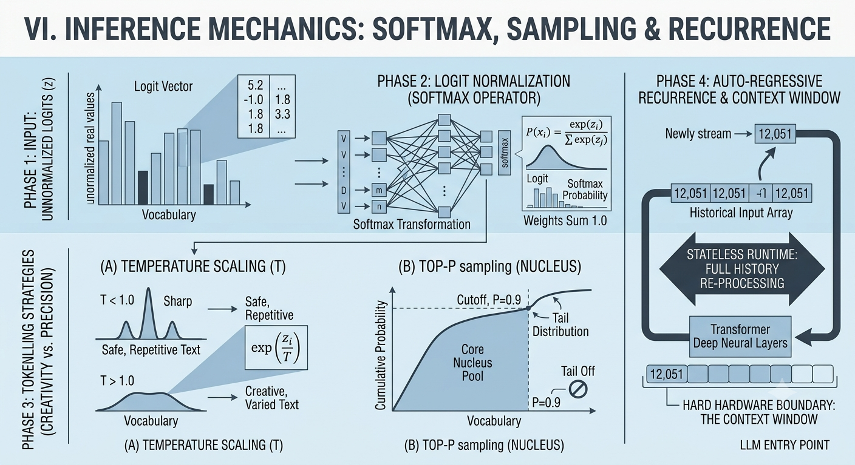
Fig 4
The Temperature parameter modifies the unnormalized logits directly before they are passed to the Softmax function, dividing each logit score by a scaling factor T. When Temperature is low (T < 1.0), it sharpens the differences between scores, making high-probability tokens even more dominant and resulting in safe, predictable text. Conversely, when Temperature is high (T > 1.0), it flattens the distribution, giving less likely vocabulary terms a higher chance of being picked and introducing creative variety into the text:
P(x_i) = exp(z_i / T) / ∑_{j=1}^V exp(z_j / T)
Top-P sampling, or Nucleus Sampling, offers a dynamic way to control token variety. Instead of looking at a fixed number of words, it sorts the vocabulary by probability and cuts off the tail once the cumulative probability hits a set threshold P. For example, if P is set to 0.90, the system only samples from the top core group of words that together make up 90% of the probability mass, filtering out unusual or irrelevant words completely.
C. Auto-Regressive Recurrence and the Stateless Architecture
Once a final token is chosen through these sampling methods, it is immediately appended to the end of the historical input token array. The entire expanded token sequence then flows back into the transformer layers to calculate the next token step. This looping process highlights a key aspect of modern Large Language Models: they have no persistent, long-term internal runtime memory between separate completion requests. Every API query or chat response is calculated independently from a blank slate.
Because the architecture is inherently stateless, the entire expanding history—including system configuration instructions, past conversation turns, and external tool or database outputs—must be re-sent and re-processed at every step. This requirement creates a major challenge when working with hardware limits: the model's Context Window. If a conversation grows larger than this hard hardware boundary, the system must use truncation or memory compression techniques to keep the total token count within safe operating limits.
The following table details how adjusting generation hyperparameters changes model creativity, precision, and alignment:
Hyperparameter Type | Operational Setting | Impact on Probability Shape | Typical Output Characteristics
Temperature (T) | Low (e.g., T = 0.2) | Accentuates peaks, dampens tail choices | Highly deterministic, formal, repetitive
Temperature (T) | High (e.g., T = 1.2) | Flattens peaks, lifts tail distribution | Highly creative, unpredictable, erratic
Top-P (Nucleus) | Narrow (e.g., P = 0.40) | Restricts pool to highest probability mass | Safe, concise, tightly focused on facts
Top-P (Nucleus) | Broad (e.g., P = 0.95) | Retains an expansive pool of valid choices | Rich, verbose, naturally fluid flow
TABLE VI: Inference Hyperparameter Settings and Emerging Behavioral Profiles
VII. CONCLUSION
A. Demystifying Cognitive Agency in Statistical Architectures
By tracking the historical development of machine intelligence from basic binary logic models to complex, multi-layered architectures, this comprehensive analysis clarifies the exact nature of Large Language Models. Rather than cognitive agents possessing genuine understanding, independent thought, or internal self-awareness, these systems are highly scaled statistical engines. They function primarily as advanced pattern-matching, predictive autocomplete platforms. Their core task is to calculate the mathematical probabilities of upcoming words based on the patterns they have observed in historical training data. The model does not comprehend concepts; it maps the structural relationships of symbols within an engineered geometric space.
The common assumption that an artificial model possesses genuine intelligence stems from its fluid linguistic output. However, this output is simply the result of mathematical optimizations processing thousands of variables simultaneously. By analyzing text data at scale, the architecture discovers structural shortcuts that mirror human logic, providing functional answers without needing actual conscious intent or semantic comprehension.
B. The Multi-Stage Optimization Pipeline
The illusion of natural, conscious dialogue is built intentionally through a multi-stage training pipeline designed to mask raw statistical probabilities behind human-like conversational styles. This system optimization is split into three foundational phases:
1) Mass Internet Pre-training: The framework ingests enormous, unstructured public web datasets to build its primary language baseline. During this phase, the model learns the syntax, grammatical structures, and general concepts of human speech by predicting hidden tokens across billions of sample sentences.
2) Supervised Fine-Tuning (SFT): To transition the system from a chaotic, next-token predictor to a helpful virtual assistant, engineers train the model on curated datasets of high-quality question-and-answer pairs. This phase teaches the network the typical tone and formatting expected in a helpful response.
3) Reinforcement Learning from Human Feedback (RLHF): Finally, response boundaries are adjusted by incorporating human evaluations. By using reward models built from human rankings, developers align the system's outputs with safety policies, factual clarity, and helpful conversational traits.
C. Summary of System Transformations
Understanding the clear line between statistical text generation and actual conscious thought is vital for developers and researchers deploying downstream applications. When these models are stripped of anthropomorphic assumptions, they can be used more safely and effectively as precise information-processing tools within enterprise software engineering.
The distinct adjustments across the three primary optimization layers of modern model development are summarized below:
Training Stage Phase | Primary Data Source | Algorithmic Focus | Emergent System Capability
Mass Pre-training | Unstructured Web Repositories | Predicting hidden tokens in text | Broad syntax and structural language skills
Supervised Fine-Tuning | Curated Q&A Response Sheets | Aligning formats to helper prompts | Helpful, clear assistant-style responses
Human Feedback (RLHF) | Human Evaluator Rankings | Optimizing for safety and utility | Polite, safe boundaries and helpful outputs
TABLE VII: Structural Adjustments and Capability Enhancements Across Training Horizons
REFERENCES
[1] A. M. Turing, "Computing Machinery and Intelligence," Mind, vol. 59, no. 236, 1950, pp. 433–460.
[2] J. Weizenbaum, "ELIZA—A Computer Program for the Study of Natural Language Communication Between Man and Machine," Communications of the ACM, vol. 9, no. 1, 1966, pp. 36–45.
[3] W. S. McCulloch and W. Pitts, "A Logical Calculus of the Ideas Immanent in Nervous Activity," The Bulletin of Mathematical Biophysics, vol. 5, no. 4, 1943, pp. 115–133.
[4] D. E. Rumelhart, G. E. Hinton, and R. J. Williams, "Learning Representations by Back-propagating Errors," Nature, vol. 323, no. 6088, 1986, pp. 533–536.
[5] P. Gage, "A New Algorithm for Data Compression," C Users Journal, vol. 12, no. 2, 1994, pp. 23–38.
[6] T. Mikolov, K. Chen, G. Corrado, and J. Dean, "Efficient Estimation of Word Representations in Vector Space," arXiv preprint arXiv:1301.3781, 2013.
[7] A. Vaswani et al., "Attention Is All You Need," Advances in Neural Information Processing Systems, vol. 30, 2017.

